Type Title of Document Here [Main Title style]
[Main Title Style]: Times new Roman, Font size 14, Bold, centred

John Firstauthor¹, Joan Secondauthor² and Marie Thirdauthor³
[Authors list]: Times new Roman, font size 10, centred. Presenting author underlined, co-authors separated by commas and last author by “and” without comma. All authors full first names. No initials and no middle names.

¹Department, Organisation, Country
²Department, Organisation, Country
[Institutions list]: Times new Roman, font size 9, italics, centred.
No postal addresses, no ZIP codes, no cities

john.firstauthor@university.org
Email address of presenting author only (Times new Roman, font size 9, centred).
Ensure it is not formatted as email hyperlink (i.e. blue and underlined).

Abstract [Heading 1 style]
[Heading 1 style]: Times new Roman, in capital letters, font size 10, bold.
Document abstract goes here. It should include a concise description of the results and findings of the research. The abstract cannot exceed one page. It must be written in English, in times New Roman, 10, single space.
The abstract can include formulas and figures: reference should appear in parentheses (Fig. 1). Bibliographical references should be referenced in the text into square brackets [1,2], Vancouver style.

[Body Text style] Lorem ipsum dolor sit amet, an pro dicunt pertinacia. Per mundi accusata imperdiet at, te diam mucius per. Qui convenire pertinacia in, ei sea admodum epicuri appellantur. Magna adipisci pericula his ea. Ea nam accusam fierent eligendi, in ius hinc officiis efficiantur.
Lorem ipsum dolor sit amet, an pro dicunt pertinacia. Per mundi accusata imperdiet at, te diam mucius per. Qui convenire pertinacia in, ei sea admodum epicuri appellantur. Magna adipisci pericula his ea. Ea nam accusam fierent eligendi, in ius hinc officiis efficiantur. Elit erat voluptua ei est, pro civibus detraxit ne, minim aliquid persecuti vim ex. Ei malis abhorreant has, eam no modus probatus. Vix unum copiosae conceptam id, at agam discere consectetuer vix. Cu pro urbanitas complectitur, an iriure nostrud docendi nam. Facer augue facilis eos ei, et nec vide mazim mollis. Lorem ipsum dolor sit amet, an pro dicunt pertinacia. Per mundi accusata imperdiet at, te diam mucius per. Qui convenire pertinacia in, ei sea admodum epicuri appellantur. Magna adipisci pericula his ea. Ea nam accusam fierent eligendi, in ius hinc officiis efficiantur. Elit erat voluptua ei est, pro civibus detraxit ne, minim aliquid persecuti vim ex. Ei malis abhorreant has, eam no modus probatus. Vix unum copiosae conceptam id, at agam discere consectetuer vix. Cu pro urbanitas complectitur, an iriure nostrud docendi nam. Facer augue facilis eos ei, et nec vide mazim mollis.
Lorem ipsum dolor sit amet, an pro dicunt pertinacia. Per mundi accusata imperdiet at, te diam mucius per. Qui convenire pertinacia in, ei sea admodum epicuri appellantur. Magna adipisci pericula his ea. Ea nam accusam fierent eligendi, in ius hinc officiis efficiantur. Elit erat voluptua ei est, pro civibus detraxit ne, minim aliquid persecuti vim ex.

[Body Text style]: Times New Roman, font size 10, text justified

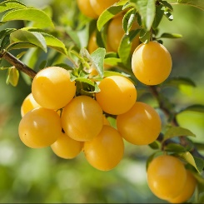  (a) | 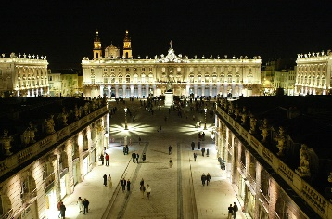  (b) | 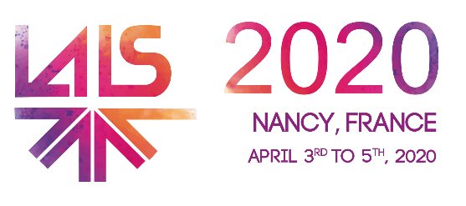  (c)

Figures: (a) Mirabelle Plums typically from Nancy, Lorraine, France - (b) Stanislas Square by night, Nancy, France
(c) official LALS 2020 logo. [Figure style]: Times new Roman, font size 19, italics, text centered

References [Heading 1 style]
[2] I. Harvey et al, Br. J. Cancer 74, 1302–1307, 1996.
[2] M. Amouroux et al, World patent WO2017093316 (A1), 2017.
[Reference style]: Times new Roman, font size 9, text justified

