Title of the Abstract
[Principal style title]: Calibri, font size 14, Bold, centered text
First Name SURNAME ¹, First Name SURNAME² and First Name SURNAME³
[Author list]: Calibri, font size 11, centered, space 1. Presenting author underlined. Co-authors separated by comas, last author preceded by "and" without coma. All authors full first names. No initials and no middles names.
Email of the presenting author
[Email]: Calibri, size 11, centered
¹ Department, Institution, Town, Country
² Department, Institution, Town, Country
[List of institutions]: Calibri, font size 10, italic, centered, space 1. No postal address, no zip code.
ABSTRACT [Heading style]: Calibri, font size 12, Capital, Bold, paragraphs spacing 6.
Lorem ipsum dolor sit amet, an pro dicunt pertinacia. Per mundi accusata imperdiet at, te diam mucius per. Qui convenire pertinacia in, ei sea admodum epicuri appellantur. Magna adipisci pericula his ea. Ea nam accusam fierent eligendi, in ius hinc officiis efficiantur. Elit erat voluptua ei est, pro civibus detraxit ne, minim aliquid persecuti vim ex. Lorem ipsum dolor sit amet, an pro dicunt pertinacia Lorem ipsum dolor sit amet, ect. [Body text style]: Calibri, font size 11, normal, justified, space 1.

KEY WORDS [Heading style]

key word 1, key word 2, key word 3, key word 4, key word 5. [Body text style + italic]

ACKNOWLEDGEMENTS [Heading style]
The authors thanks… [Body text style + italic]

REFERENCES [Heading style]
- McCaffrey, B.J., Quintiere, J.Q. and Harkleroad, M.F. (1981) Tittle of the publication, Journal title 17:98-119, http://dx.doi.org/10.1007/BF02479583
- Drysdale, D., Tittle of the book, Editor, Chichester, year, p. 146. [References style]: Body text style

FIGURES [Heading style]
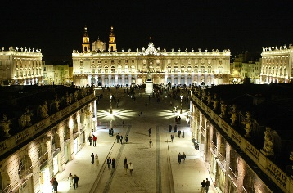

Fig. 2. Logo of MBP’2022 conference.
[Caption style]: Calibri, font size 11, centered text.

Fig. 1. Stanislas Square by night, Nancy, France.
[Caption style]: Calibri, font size 11, centered text.

TABLES [Heading style]
Table 1. Affinity constant between peptides and metal ions determined in SPR.
[Style of the table caption]: Calibri, font size 11, text centered
Column 1 | Column 2 | Column 3
Align the text left in the table lines for a better lisibility ª. | 31 | 449.6
Text 1 | 30 | 88.8
Text 2 | 29 | 516.5

ª The notes are referenced under the table by exposing letters.
[Style of the notes]: Calibri font size 10, space 1, text justified.

